Software Release Notes



PA06520 – Personal Update Service
www.ngahr.com

Distribution

- HR Support NorthgateArinso

Document Control
Change Control Table
Version | Description | Release Date
1.00 | Initial Release | 09/07/2014
1.10 | Updated Release | 16/07/2014

Document Details

Prepared by: | Wasim Khan
Document ID: | 0000.doc
Status: | Initial Release
Version: | 1.10
Date of release: | 16/07/2014
NGA Human Resources Ref: | PA06520

Copyright
The contents of this document and all associated computer programs and documentation are copyright and may not be reproduced without the written permission of NorthgateArinso UK Limited. This document does not constitute an offer of a contract or the basis of a contract and NorthgateArinso UK Limited reserves the right to change all or any part of this document without notice.
Some sections may refer to statutory regulations or requirements. It must be stressed that this document is not a substitute for official forms of notification or information, nor is it a definitive statement of the law.
ResourceLink is a registered trademark of NorthgateArinso UK Limited.
Any other trademarks mentioned herein are the property of their respective owners.
© 2014 NorthgateArinso UK Limited. All rights reserved.

Contents
1 Introduction 4
2 User Instructions 5
2.1 High level service description 5
2.2 Service Invoke Mechanism 6
2.3 Initial Data Setup 6
2.3 Web Service Input Details 10
2.4 Web Service Output Details 10
2.5 Field Mapping 13
2.6 Data Structure Definition 14
2.7 Error Handling 22
2.8 Schema/WSDL Details 32
2.9 Validations 32
2.10 Assumptions & Dependencies 33
2.11 HR Interface Validations 33
2.12 HRInterface Changes 33
3 Items Released 35
3.1 ResourceLink Service Build 35
3.2 Database Scripts 35

Introduction

These software release notes are written to accompany the release of new functionality around ResourceLink, to provide an effective integration between ResourceLink and IT Registration, as a part of their new HR/Payroll implementation project.

Included in this document are brief instructions on how to use the functionality, as well as a list of software and files released, and any tasks, menus or base data that needs to be set up before it is executed.

User Instructions

An existing service called ModifyEmployeeService which is in development under PA06515 has been amended to receive a daily feed from the from IT Registration System to create or update the details specific to one or multiple employees in ResourceLink, using the input data received from the IT Registration System. The data being sent is Username, Phone Number and Email Address along with the employee number where username would be the Active Directory username.

High level service description

This existing service will receive a daily feed from IT Registration System that will contain the details specific to one or multiple employees. The input will include parameters Username, Phone Number Employee Number and Email Address where username would be the Active Directory username.

The web service will act as a medium, between ResourceLink and IT Registration system. It will receive a daily feed from IT Registration system, perform basic validations like verifying whether the mandatory parameters are received or not etc., and then sends the request to HR Interface. HR Interface acts as a means of communication between the Web Service and ResourceLink. It extensively validates the request and upon successful validation, and passes the data to ResourceLink, where the details are stored against the respective employees specified in the request. The communication will be done as displayed below:

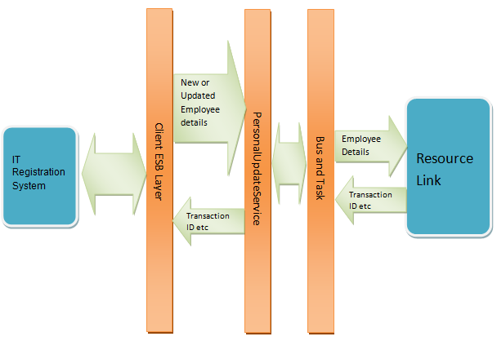

Web Service Details

Scope Parameters | Details
Name | ModifyEmployeeService
Existing/New | Existing (Reference to PA06515)
Standalone Web Service | Yes
Encoding Parameter | UTF-8

Service Invoke Mechanism

The Web Service will be invoked using Simple Object Access Protocol (SOAP) messages. SOAP is a lightweight messaging protocol that allows objects of any kind, on any platform, written in any language to cross-communicate. SOAP messages are encoded in eXtensible Markup Language (XML) and will be transported over HTTP/HTTPS. The web service is loosely coupled and can dynamically locate and interact with other components on the internet to provide services.

Initial Data Setup

The base data scripts mentioned in section 3.2 have been executed so that the requirement can be tested.

The below steps should be followed to set up ModifyEmployeeService:

1st create a new SOAP project by clicking on the Projects navigator as displayed below and select New SOAP Project :

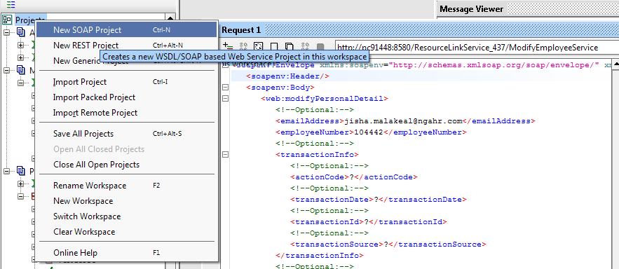

Enter the WSDL link in the ‘Initial WSDL field’ for new SOAP project window and click ok as displayed below:

For local testing we have used the following link - http://pc91448:8580/ResourceLinkService_441/ModifyEmployeeService?wsdl. Therefore all URLs in the screenshot have the above URL. However, on UOS system this will be URL where the SOAPUI tool is hosted.

The new project will be added on the left hand list of Projects as displayed below. Two new methods added as show below which are: modifyPersonal Detail and modifyPersonal Details

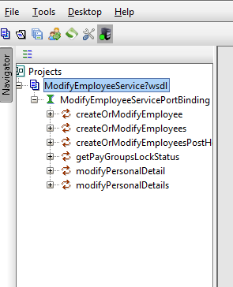
Expand these two methods as displayed below:
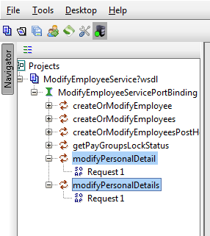

Illustration of the 1st method being used - modifyPersonal Detail

Double click on Resquest1 – the below screen will display:
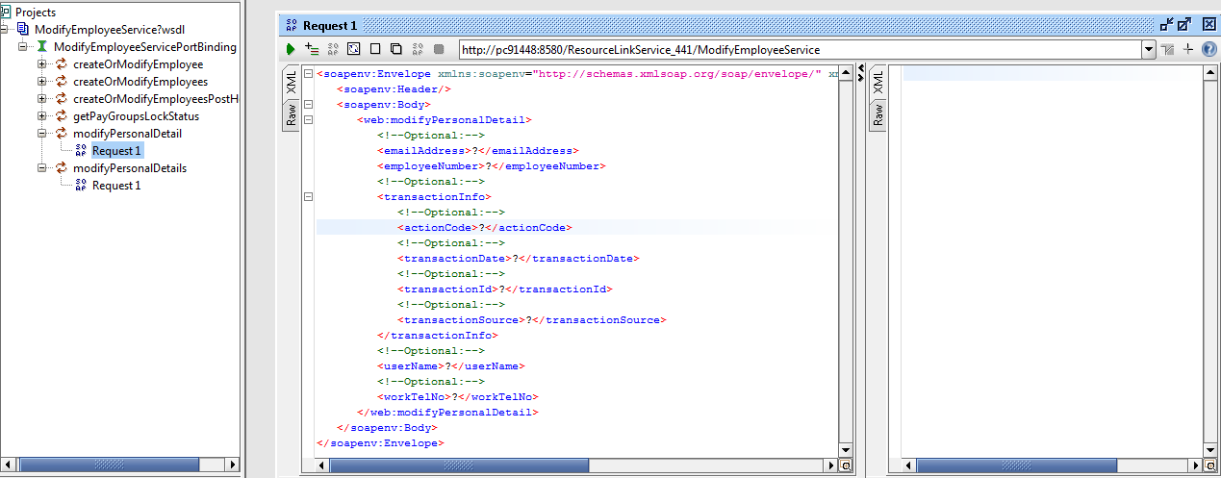

Now you can input field values and receive the synchronous response on the right side displayed below:

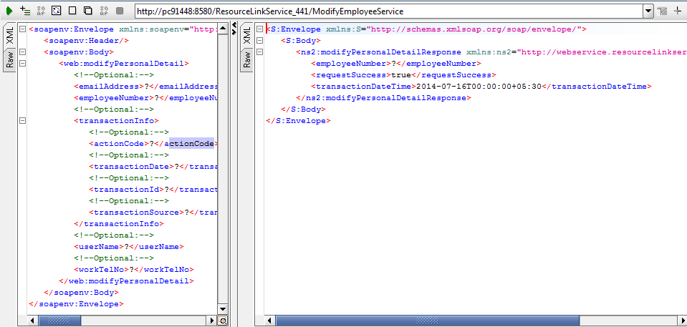

If synchronous response is success then request will be passed to the HR Interface and the response will be received through asynchronous response. (Refer earlier document for asynchronous setup)

The same can be done for the 2nd Method - modifyPersonal Details

Note: You can send multiple requests using the 2nd method. An example displayed below.

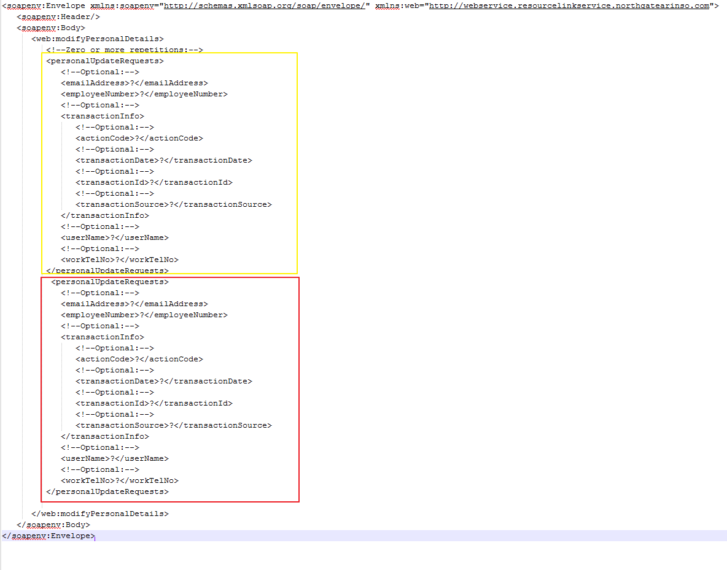

The below steps should be followed to receive asynchronous response:

1st create a new SOAP project by clicking on the Projects navigator as displayed below and select New SOAP Project :

Enter the WSDL link in the ‘Initial WSDL field’ for new SOAP project window and click ok –

For local testing we have used the URL – http://pc91448:8580/ResourceLinkService_437/AsynchronousResponseService?wsdl, but on customer system this should point to the test WSDL location.

The new project will be added on the left hand list of Projects as displayed below:

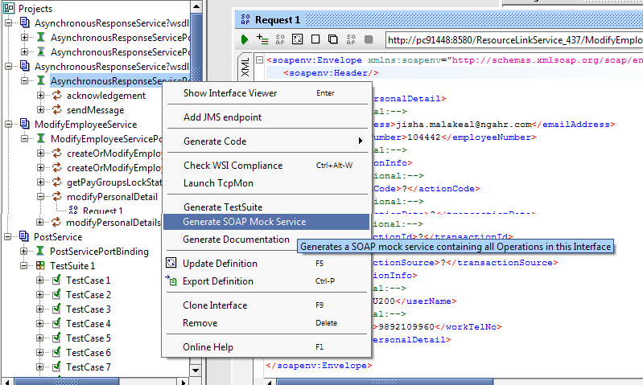

Click on the Generate SOAP Mock Service option

Check in ResourceLink system control screen (to reach this screen enters HR97S8 in the fast path).Select Web applications – Click on RL service – The below screen will display:

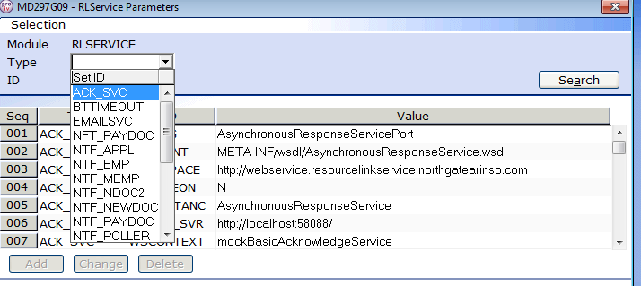

Select ACK_SVC from the Type dropdown, tab through ID , the below screen will display :
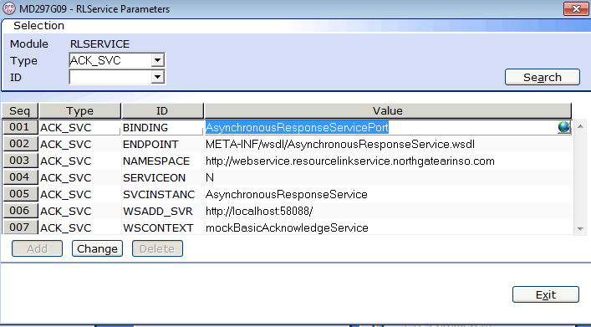

The result which displays from 3 to 9, except point 8, in the table, the same data should match in your database.

In the Generate MockService window the following information should be entered:

Path : /mockBasicAcknowledgeService
Port: 58088

This data should match with the data available in the D993M table as displayed above.

After this the below window will appear:
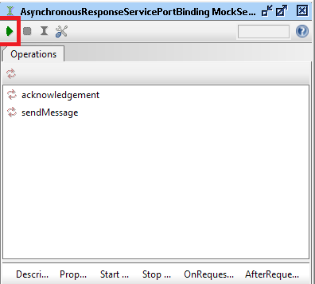

Select the start icon as highlighted above. This will start the asynchronous mock service.

Illustration of an Input request and synchronous response:
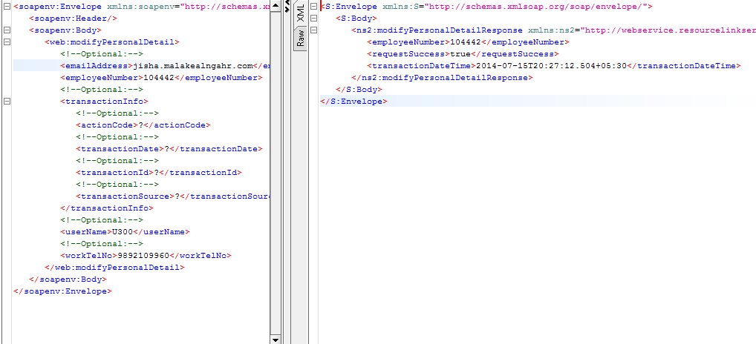

Now go on the asynchronous response mock service window and double click on the response :

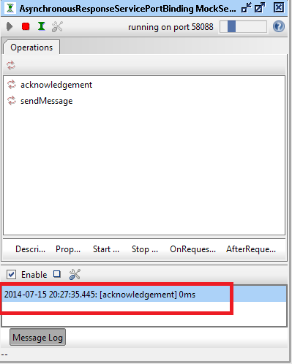

A message window will appear as displayed:
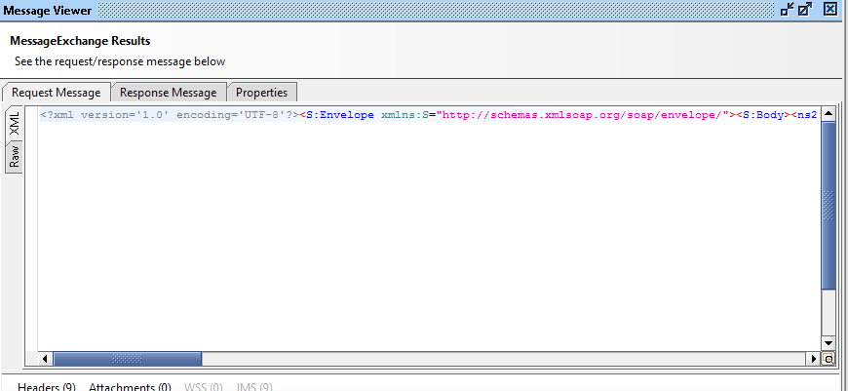

Right click on the window and select format XML option. The Asynchronous response will display as displayed below :

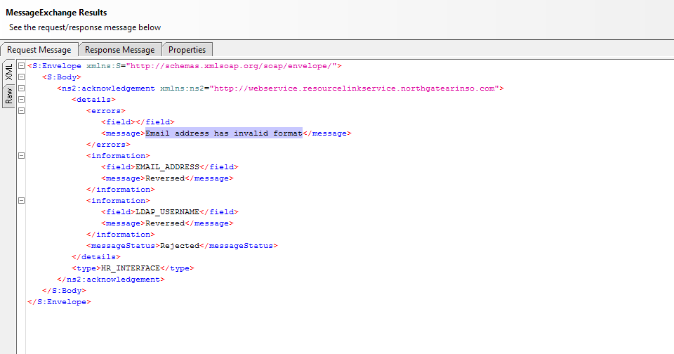

2.3 Web Service Input Details

The following input parameters will be passed to the web service:

Input Parameter | Data Type | Acceptable Values | Max Length in Characters | Nullable – Add | Nullable – Update
Employee Number | String | Alphanumeric | 10 | N | N
Username | String | Alphanumeric | 50 | Y | Y
Phone Number | String | Alphanumeric | 20 | Y | Y
Email Address | String | Alphanumeric | 80 | Y | Y

  - Web Service Output Details

The following details are sent as the output for the webservice:

Output Parameter | Data Type | Data Returned | Nullable | Existing/  New
information | String | Contains two child elements called field, which will display the field name, and message, which will display the message related to that field | field –N  message – Y | New
messageDate | DateTime | Date and Time of the transaction | N | New
messageId | String | A unique alphanumeric transaction ID generated by HR Interface. | N | New
messageStatus | String | The status of the request, “Accepted” or “Rejected” | N | New
warnings | String | Contains two child elements called field name, which will display the field for which the warning is received, and message, which will display the warning message related to that field. | field –N  message – N | New
Errors | String | Contains two child elements called field, which will display the field name for which the error is received, and message, which will display the error message related to that field | field –N  message – N | New
type | String | The application which processes the transaction would be returned, in this case it would always be “HR_Interface” | N | New

The response consists of the list of fields that are added or updated as a part of that transaction. However, the old and/or new values for these fields will not be sent in the response.

The warnings and/or errors will only be received in the response if the warnings and/or errors are generated when the request is processed. If this is the case, these elements cannot be null. However, if the warnings and/or errors are not generated, these elements will not appear in the response at all.

Every response from this service is prefixed with “<?xml version="1.0" encoding="UTF-8" ?>”. This ensures that the XML output handles Unicode data.

Field Mapping

The table below provides the mapping between the input data sent via the web service and the corresponding fields (and screen) where the data will be posted once the transaction is completed.

ModifyEmployeeService Canonical Model | WSDL Element Name | RL Screen Number – Description | RL Field Name | Existing/New
Employee Number | employeeNumber | MD55S22 – Employee Selection Screen | Employee Number | WSDL – New  RL – Existing
Username | username | MD97G23 – ResourceLink Web framework LDAP mapping | LDAP | WSDL – New  RL – Existing
Phone Number | workTelNo | MD55G3A – Maintain Contact Numbers | Work Phone Number | WSDL – New  RL – Existing
Email Address | emailAddress | MD030G7 – Maintain Email Address | Email | WSDL – New  RL – Existing
actionCode |  | This field is for transaction purpose only and hence the data in this field will not be posted to ResourceLink | NA | WSDL – New  RL – NA

Data Structure Definition

The data structure used for this webservice is:

Request Data Structure:

Struct ModifyPersonalDetails
{
Struct ModifyPersonalDetail[] requests;
};

Struct ModifyPersonalDetail
{
string employeeNumber;
string username;
string emailAddress;
number workTelNo;
Struct TransactionInfo transactionInfo;
};

Struct TransactionInfo
{
string actionCode;
dateTime transactionDate;
string transactionId;
string transactionSource;
};

Response Data Structure:

Synchronous Response – this is an acknowledgement that the request has been received and has been added to the queue.

Struct ModifyPersonalDetailResponse
{
string employeeNumber;
boolean requestStatus;
dateTime transactionDateTime;
string transactionId;
};

Asynchronous Response - this is the final response that is sent back after the request has been processed and removed from the queue. The WSDL for this is AsynchronousResponseService which is different from the modifyEmployeeService WSDL and needs to be bound separately.

Struct acknowledgement
{
Struct details details;
String type;
};

Struct details
{
String description;
Struct validationError errors;
Struct validationError information;
Struct validationError warnings;

String messageId;
String messageStatus;
};

Struct validationError
{
String field;
String message;
validationErrorType type;
};

    - XSD

The XSD for this inbound service is:

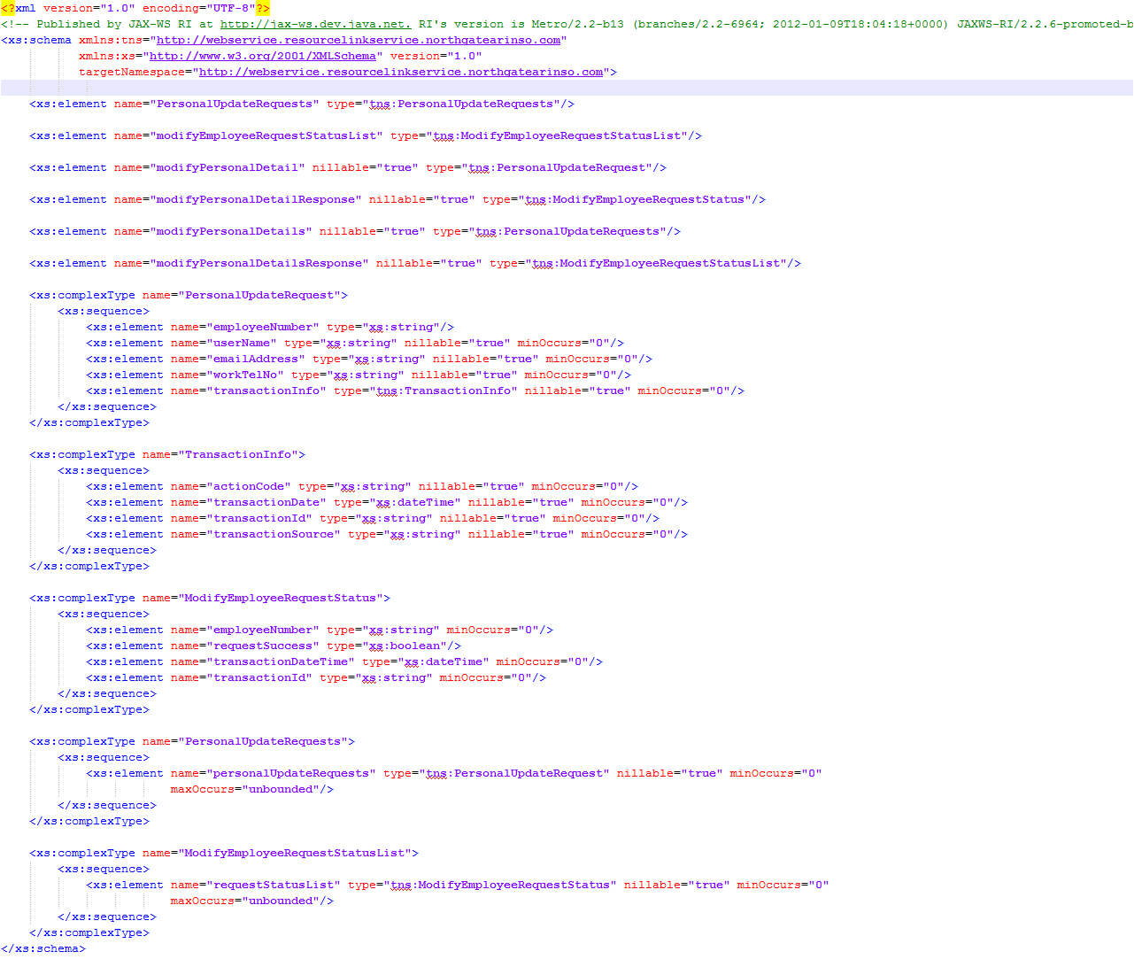

    - Communication Protocol

The communication protocol used for this service is SOAP (Simple Object Access Protocol) over HTTP/HTTPS.

    - Message Format

The XML schema that is posted during the input sent via the web service is given below:

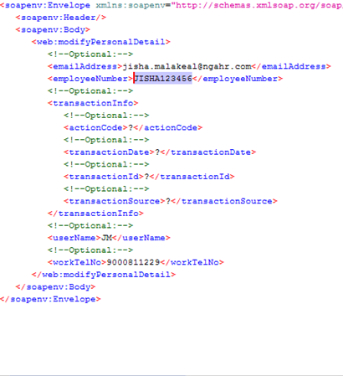

The XML that is posted back after updating the details in ResourceLink and pass the transaction to another service called Asynchronous service:

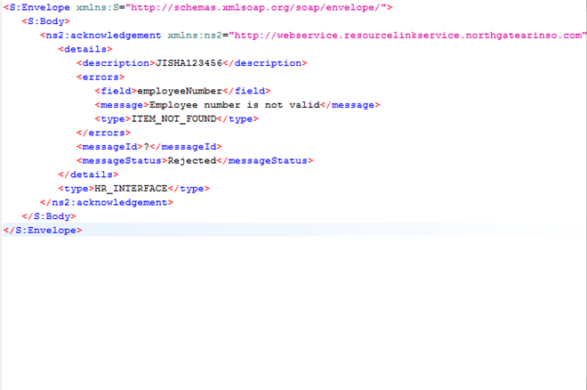

    - Access Frequency

The service can be invoked as and when required by IT Registration to add or update the employee specific data in ResourceLink.
    - Operations supported by the Web Service

The following 2 operations are supported by the web service:

Add
- If the active directory username specified in the incoming request does not exist for the employee number specified in the request:
  - The service will add the new username for the employee in ResourceLink and then update the details against that employee as mentioned below.

The username sent in the request is assumed to be the internally mapped LDAP username for the employee number send in the request. The internal mapping of the employee number to the LDAP username is saved in the D1910M table which can be viewed in RLA screen MD97G23 – ResourceLink Web Framework LDAP Mapping as shown below:

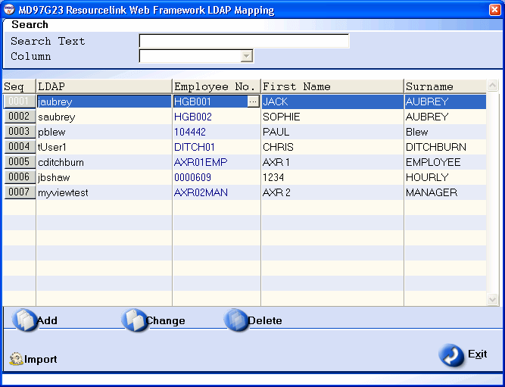

The above mapping table will be used when the Map Internally field is checked in the below screen (MD97G76 – ResourceLink Web Framework LDAP Parameters)

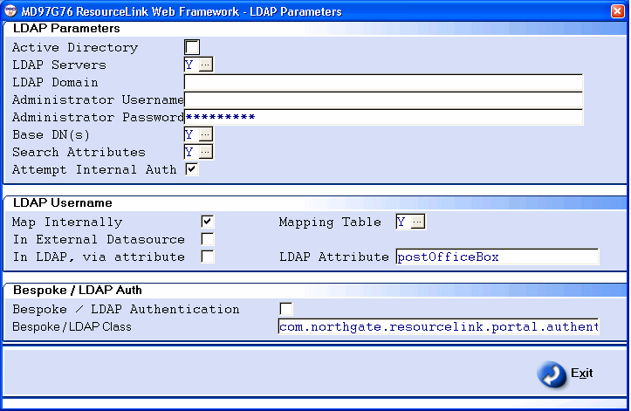

This option (Map Internally) allows the customer to specify that the network logins to employee mappings are held in an internal table. These mappings are entered via the Mapping Table described above. This method expects that each employee who requires access to MyView requires a mapping in this table. For every MyView user a record must exist in this table, without which they will not be able to access MyView. These mappings will be stored in the table D1910M.

The employees would be created, either via the ModifyEmployeeService, or manually within RL by HR staff. The username employee mapping will not be created as part of this process.

Subsequently and at a later point this webservice ie. ModifyEmployeeService will be called to update these details into RL and a record will be added to D1910M via this webservice.

The email and phone numbers would be added/updated in the employee record after the validations are performed by HR Interface.

Update
- If the data is present for the employee specified in the request:
  - The service will update the details of the employee with the incoming data.

    - Source & Target Systems
Source System | IT Registration
Destination System | ResourceLink

    - Security Requirements

The Security requirements is under discussion and will be dealt in a separate requirement and a new specification will be created to list all security related changes made for the web service framework which will be common to all web services.

As part of this requirement there is no security related changes made.
    - Data Encryption

There would be no data encryption done as part of this development.

Error Handling

Below are the list of Error messages which will be returned by the Web Service.

- Input parameter length is more than Max length for – Username

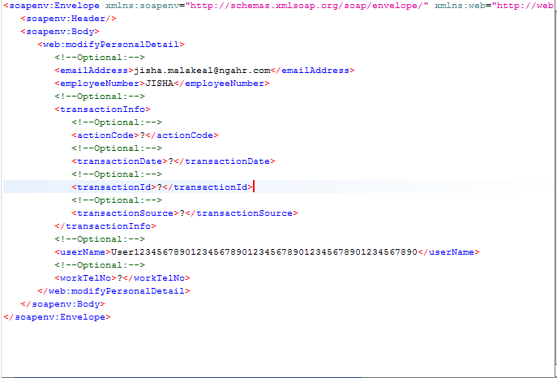

Asynchronous Response

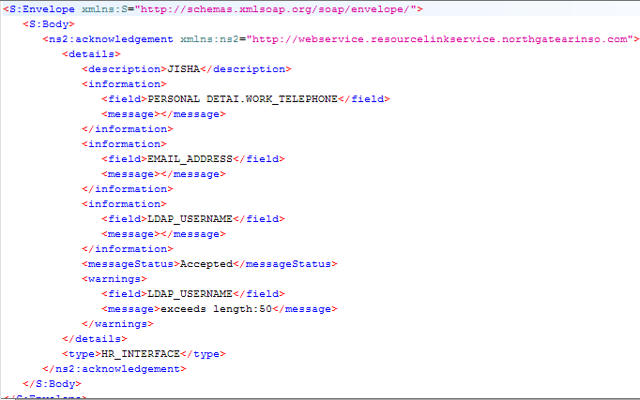
- Input parameter length is more than Max length for – Phonenumber

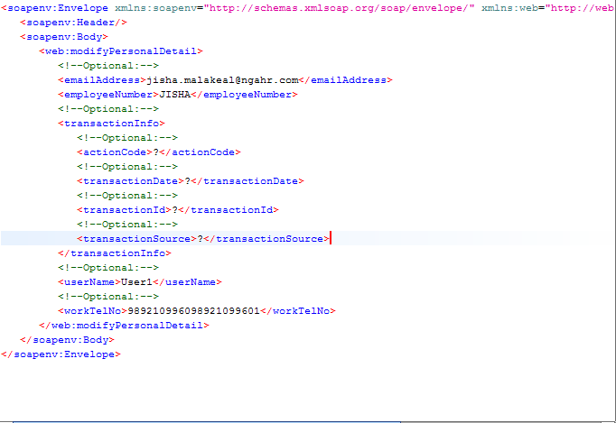

Asynchronous Response

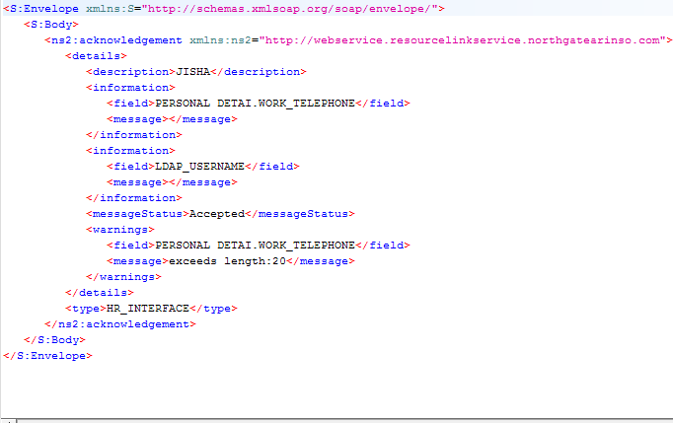

- Input parameter length is more than Max length for – Email

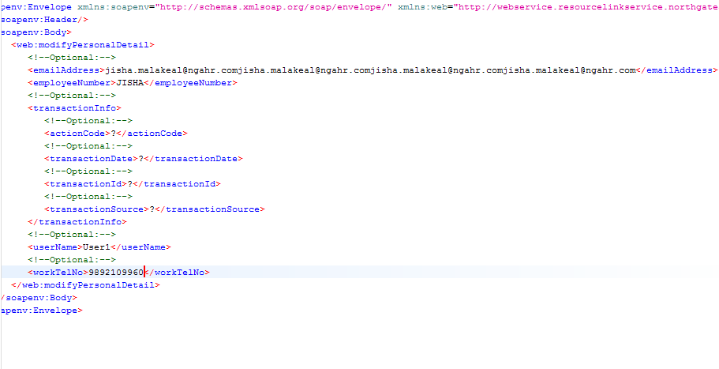

Asynchronous Response

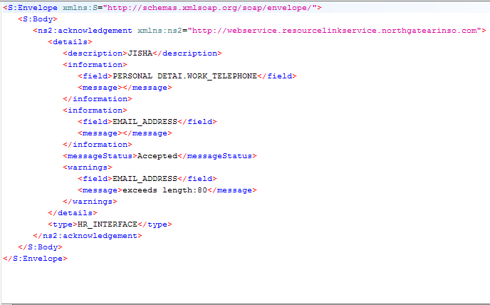

- Employee number and username does not exist in D1910M

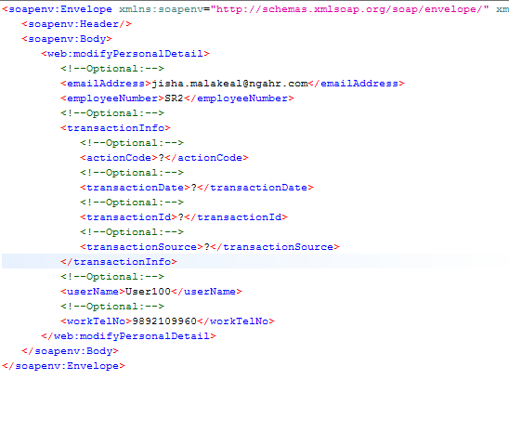

Asynchronous Response

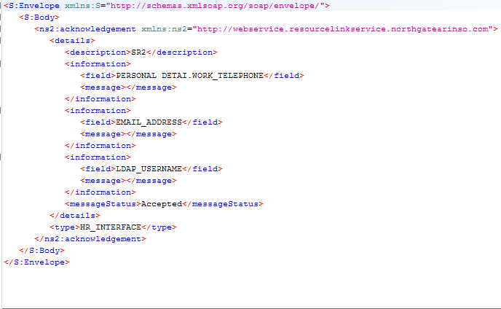

- Employee number exist and username does not exist in D1910M

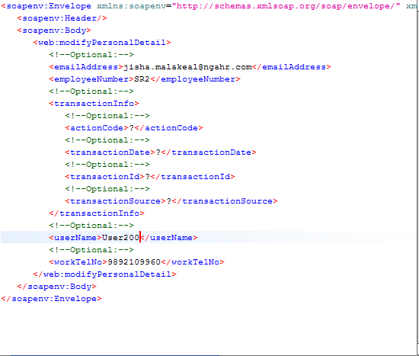

Asynchronous Response

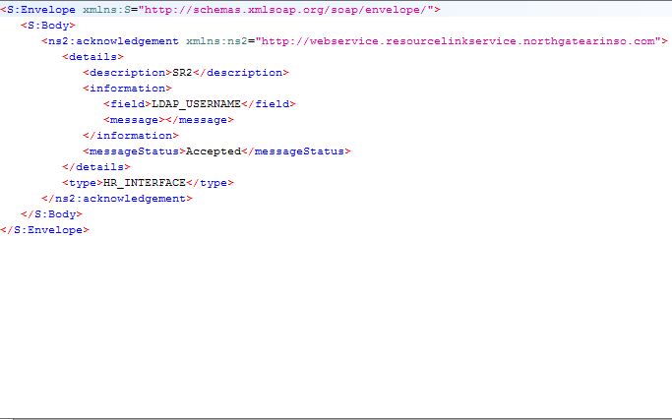

- Employee number and username exist in D1910M

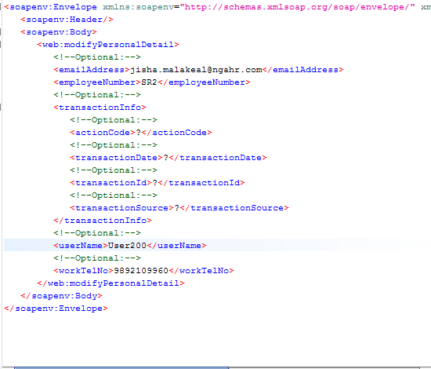

Asynchronous Response

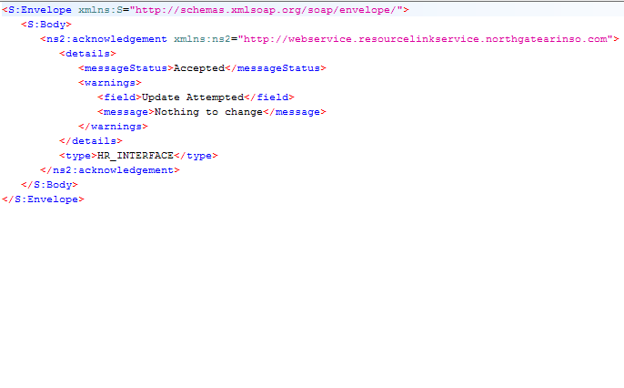

- Employee being paid for current period.

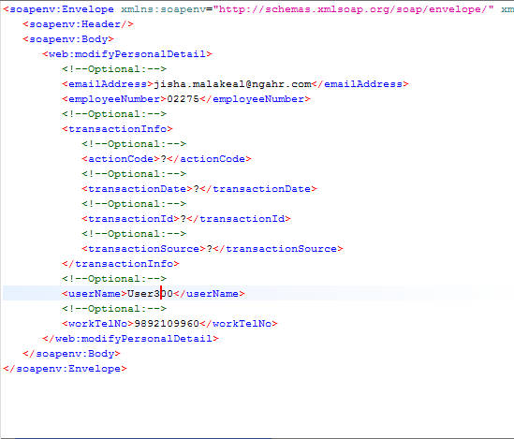

Asynchronous Response

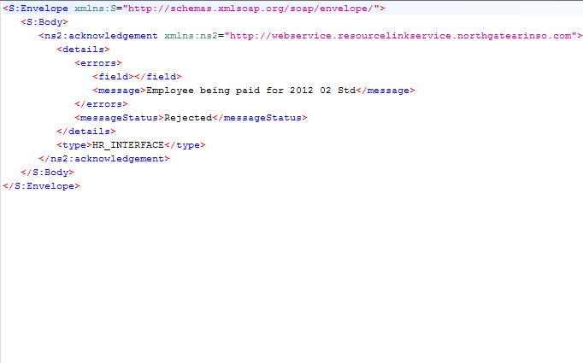

- Update username as Blank/null.

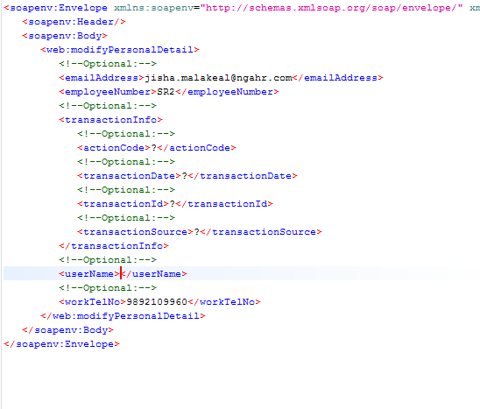

Asynchronous Response

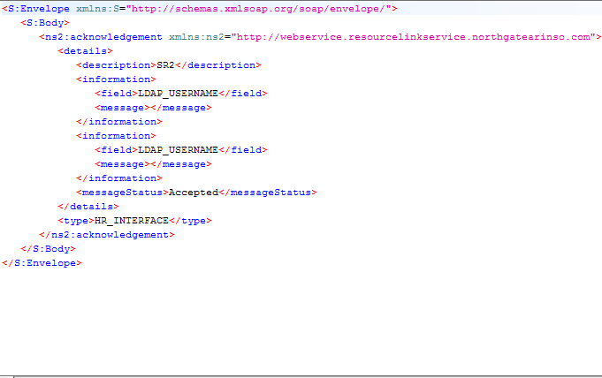
- Input parameter when employee number is not Valid.

Asynchronous Response

Schema/WSDL Details

The WSDL and XSD are sent along with the release notes, file names are:
- ModifyEmployeeService.wsdl - The WSDL for this service.
- ModifyEmployeeService.xsd - The XSD for this service.

Validations
The following validations are performed before submitting the incoming request for processing:

- Mandatory Parameters – The Web service verifies if all the mandatory parameters are received or not. If not, an exception is thrown back to the source system. If the mandatory input parameters are received in the request, the request is processed and passed to a HR Interface routine for further processing.
- In case of an update request, all the new values are compared to the existing values of the respective fields, and the fields with the changed values would then be updated. However, if the old and the new values of all the fields are the same, the web service would treat this request as a successful update request, even though none of the details will be updated.
- Delete – the work telephone and the email data will be deleted if the web service receives an empty input for these fields. If the username field is received as blank then web service will delete the records for this employee from D1910M which will then indicate that the user cannot login to MyView using the LDAP username, and can only login using the internal authentication provided the “Attempt Internal Auth” field is checked in screen MD97G76 – ResourceLink Web Framework – LDAP Parameters. The employee number field is a mandatory field and hence should always be passed otherwise the request will be rejected.
- Web service checks if the employee number received is an existing employee within the system, if the employee does not exist then the request will be rejected.
- If the request is received for an employee who is currently being paid and being processed for a pay cycle, the request would be rejected.
- Update - When a username is received in the request which is existing in D1910M but the employee number in the request is different than the one existing in the table HR Interface does the following :
- Deletes the record for the username received in the request.
- Adds a new record for the username employee number received in the request.
This change is to ensure that one username can only be mapped to one employee number.
An Employee Number could have one or more usernames.

Assumptions & Dependencies

The following assumptions have been made with respect to the incoming data:

- The username received as request would be assumed to be the LDAP username for the employee and would be saved in D1910M table which holds a one to many mapping between the employee number and the LDAP username, hence one employee number can be attached to multiple LDAP usernames.
- If the length of the value sent by the source system is greater than the maximum length supported by that field in the RLA database, then UoS will truncate this value and send the truncated value to the web service. If still a value with length greater than the maximum length of the field is received, the request would be rejected.
- The fields for which there is no update (i.e. in case of a modify operation) should not be passed in the request, even as empty or closed tags, as the service will delete the existing values for these fields and make them null in ResourceLink.
- The changes listed in this document are only applicable to MyView users. These do not cover operator logins within ResourceLink.
- Within the LDAP parameters the configuration should be such that the Map Internally needs to be checked, only then would MyView use the internal table (D1910M) to check the mapping between username and the employee number. When map internally is checked MyView will first check the record in D1910M. If a record exists for the entered username, only then a call will be made to check the username/password to active directory for user authentication purposes.
- If the employee number send in this request is not present in the system then the request will be rejected.

HR Interface Validations
- HR Interface routine will re-verify whether the mandatory parameters are received or not.
- HR Interface will verify whether a valid data type value is received in the input or not.
- HR Interface will verify whether the date input is in the correct format or not.
- HR Interface will verify whether the length of the fields received in the input is more than the maximum possible length of those fields.

HRInterface Changes
The HR Interface Bus and Task process is used to update an employee’s data in ResourceLink Aurora.

Existing record types will be used to update Home Telephone Number and Email Address (10PERDET, HOME_TELEPHONE, EMAIL_ADDRESS).

A new record type of 121LDAPUSER has been introduced to allow an Employee’s LDAP username to be updated:

121LDAPUSERNAME – LDAP Username

Field ID | Max  Length | Notes
LDAP_USERNAME | 50 | LDAP Username
LDAP_ACTION | 1 | "I" or blank – New Username,  "D" – Delete record (if this is passed with no LDAP Username value, then all usernames against the employee will be deleted).

Items Released

ResourceLink Service Build

The functionality is available in the following build:

Build Number | Build Name
434 | ResourceLinkService_434.war

Database Scripts

The following database scripts are included as part of this functionality:

Script Name | Description
Base Data Script | SQL_PA06520_ORA.sql - To create the data from the LDAP import for HRI

